**Burndown:**

Take a screenshot of your team's Burndown Chart and submit it here.

**Evaluate and present how your individual contribution has impacted the progress of the project.**

This week I worked on the following tasks:

The dialog box features I was working on became completely corrupted so I had to start it from scratch. I was able to fine tune the text box range of activation and deactivation so that you had to be directly upon the activation zone to activate, but the dialog box would not disappear until the player moved much further away. The smooth animations of dialog box appearing and disappearing was fixed. It was an unfortunate setback, but I was able to recreate what was needed and even improve upon it.

**Indicate if you are behind, ahead, or on schedule for completion of the current milestone. Discuss what is impacting the schedule.**

I am behind because of the corruption of the dialog box feature. I will continue to make progress and keep adding features.

**Work Log Hours:**

All students need to submit a weekly screenshot of their individual Production Plan in order to earn any points for their Sprint Logs.

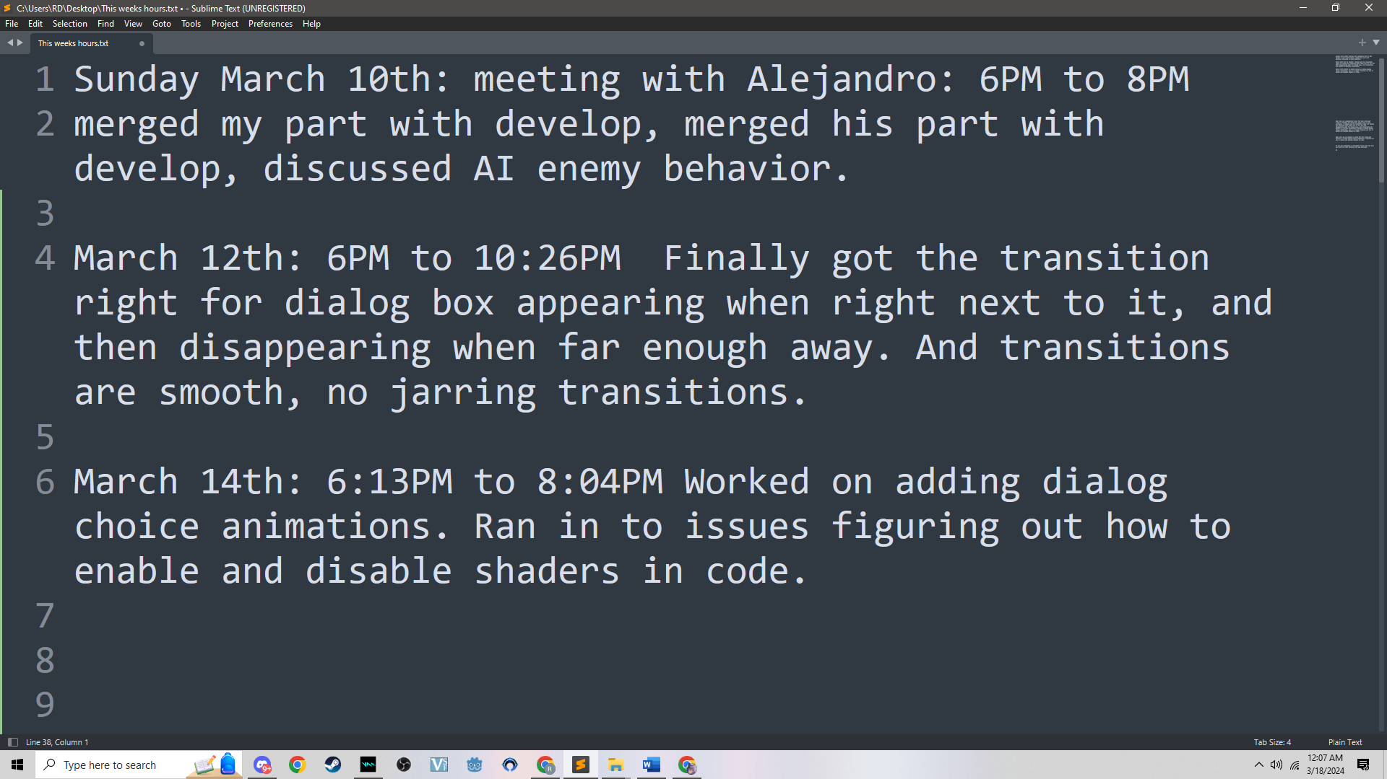

**Work Log Instructions:**

***Task:*** The ID or name of the task you are documenting.

Meeting with Alejandro

Rebuild Dialog Box from Scratch – Work on appearing and disappearing using multiple area2D nodes

Rebuild Dialog Box from Scratch – Using shaders to show dialog choice interactions

***Work Description:*** A brief description of the work you completed for this task.

Sunday March 10th: meeting with Alejandro: 6PM to 8PM

merged my part with develop, merged his part with develop, discussed AI enemy behavior.

March 12th: 6PM to 10:26PM Finally got the transition right for dialog box appearing when right next to it, and then disappearing when far enough away. And transitions are smooth, no jarring transitions.

March 14th: 6:13PM to 8:04PM Worked on adding dialog choice animations. Ran in to issues figuring out how to enable and disable shaders in code.

***Screenshots / Video of Work:***

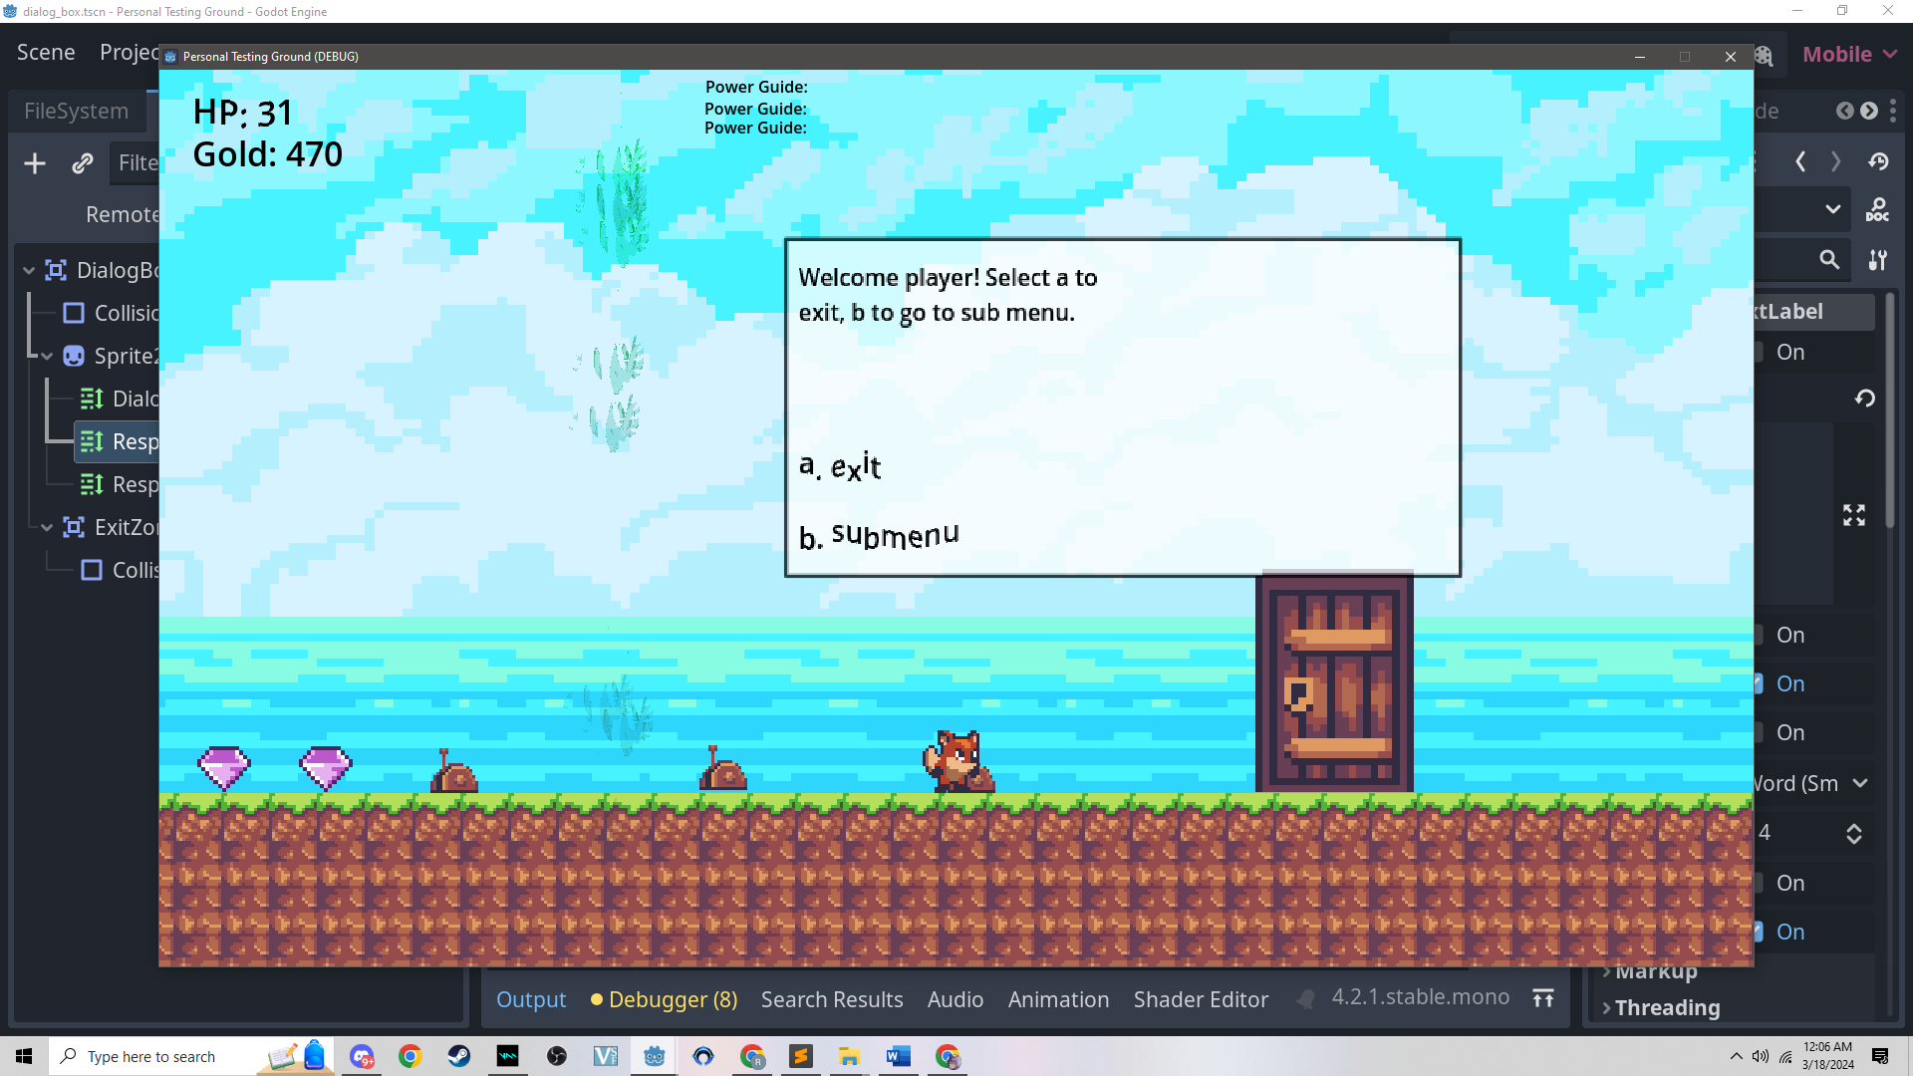

***Estimate:*** Estimated time for each task.

Rebuild Dialog Box from Scratch – Work on appearing and disappearing using multiple area2D nodes – 4 Hours

Rebuild Dialog Box from Scratch – Using shaders to show dialog choice interactions – 4 Hours

***Daily Hours:*** Hours actually worked on for each task.

Rebuild Dialog Box from Scratch – Work on appearing and disappearing using multiple area2D nodes – 4 hours and 26 minutes

Rebuild Dialog Box from Scratch – Using shaders to show dialog choice interactions – 2 Hours

**Stand Ups:**

***What have you accomplished since the last stand-up?***

I had to recreate the dialog box scene since it got corrupted. I Finally got the transition right for dialog box appearing when right next to it, and then disappearing when far enough away. And transitions are smooth, no jarring transitions. Worked on adding dialog choice animations. Ran in to issues figuring out how to enable and disable shaders in code.

***What will you be working on until the next stand-up?***

Working on fixing dialog choice animations. figuring out how to enable and disable shaders in code.

***Do you have obstacles or anticipate issues that may slow you down? (or what obstacles did you overcome)***

I will not have any road blocks.

**Team Submission**

<https://drive.google.com/file/d/11Y5F7D8HACw_TQbcrFwCNFcLiS8iP2WW/view?usp=sharing>